**The 2014 Derby and Derbyshire Declaration on improving outcomes for people experiencing mental health crisis 11th December 2014**

We, as partner organisations in **Derby and** **Derbyshire** will work together to put in place the principles of the national **Concordat** to improve the system of care and support so that people in crisis because of a mental health condition are kept safe. We will help them to find the help they need − whatever the circumstances − from whichever of our services they turn to first.

We will work together to prevent crises happening whenever possible, through intervening at an early stage.

We will make sure we meet the needs of vulnerable people in urgent situations, getting the right care at the right time from the right people to make sure of the best outcomes.

We will do our very best to make sure that all relevant public services, contractors and independent sector partners support people with a mental health problem to help them recover. Everybody who signs this declaration will work towards developing ways of sharing information to help front line staff provide better responses to people in crisis.

We are responsible for delivering this commitment in **Derby** and **Derbyshire** by putting in place, reviewing and regularly updating the attached action plan.

**This declaration supports ‘parity of esteem’ (see the glossary) between physical and mental health care in the following ways:**

* Through everyone agreeing a shared ‘care pathway’ to safely support, assess and manage anyone who asks any of our services in **Derby and** **Derbyshire** for help in a crisis. This will result in the best outcomes for people with suspected serious mental illness, provide advice and support for their carers, and make sure that services work together safely and effectively.
* Through agencies working together to improve individuals’ experience (professionals, people who use crisis care services, and carers) and reduce the likelihood of harm to the health and wellbeing of patients, carers and professionals.
* By making sure there is a safe and effective service with clear and agreed policies and procedures in place for people in crisis, and that organisations can access the service and refer people to it in the same way as they would for physical health and social care services.
* By all organisations who sign this declaration working together and accepting our responsibilities to reduce the likelihood of future harm to staff, carers, patients and service users or the wider community and to support people’s recovery and wellbeing.

**The Health and Well Being Boards of Derby and Derbyshire have agreed that the organisations and the communities they represent should be working together in supporting the Mental Health Concordat.**

**The signatures below are those with a statutory duty.**

**We, the organisations listed below, support this Declaration. We are committed to working together to continue to improve crisis care for people with mental health needs in DERBYSHIRE.**

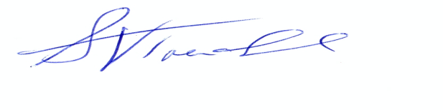

**Steve Trenchard** Chief Executive

Derbyshire Healthcare NHS Foundation Trust



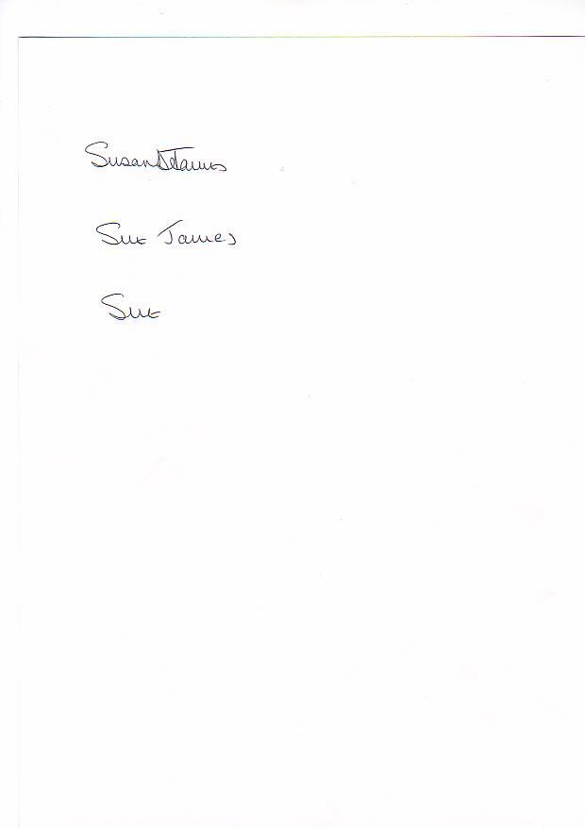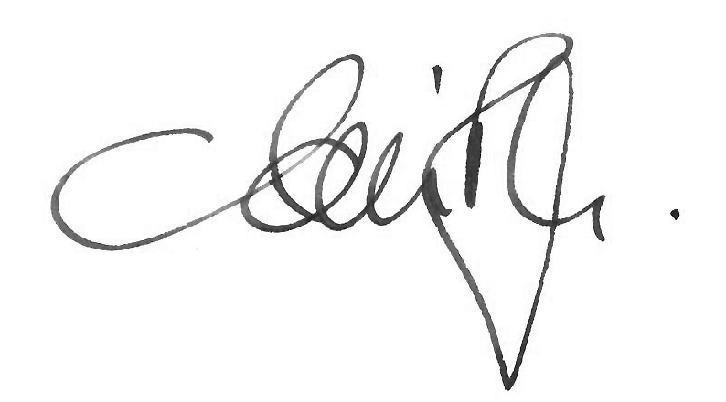

**Gavin Boyle** Chief Executive Officer **Susan James** Chief Executive Officer







**Andy Gregory** Chief Officer **Andy Layzell** Chief Officer



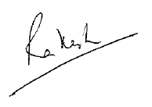

**Jackie Pendleton** Chief Officer **Rakesh Marwala** Chief Officer







**Judith Douglas Martin Fahy,**

Director of Nursing & Quality SCN Manager Mental Health

****East Midlands Ambulance Service NHS Trust



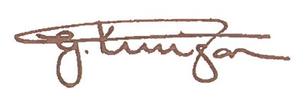****

**Alan Charles Gary Knighton** Assistant Chief Constable

Police and Crime Commissioner for Derbyshire Operational Support



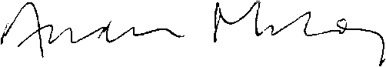

**Andrew Milroy Superintendent Edward Wylie**

Derbyshire County Council Adult Care British Transport Police

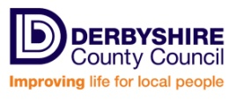



**Councillor Martin Repton Tracy Allen**

Cabinet Member Adult Care and Health Derby City Chief Executive

Derbyshire Community Health Services

[https://encrypted-tbn0.gstatic.com/images?q=tbn:ANd9GcTnBbTLQqhF0FNntOulFwkNcrJBuEG2yhMBbzU3RHHW4Oi86lfQG714uA](http://www.google.com/url?url=http://www.derby.gov.uk/&rct=j&frm=1&q=&esrc=s&sa=U&ei=JV6IVNbKG6S17gaEl4DgDA&ved=0CBYQ9QEwAA&usg=AFQjCNF1OQCRpVwrc_PsuOK6AZTZQKP2sA)NHS Foundation Trust

**On behalf of the Mental Health Voluntary Sector across Derby and Derbyshire:-**

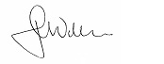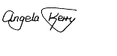

**Jackie Willis**  **Angela Kerry**

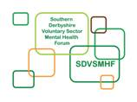Manager NDVA Manager SDVSMHF

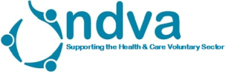

**On the 25th June 2014 The Police and Crime Commissioners and the NHS organised a Mental Health Summit. At the summit we signed a large A1 version of the Crisis Concordat Declaration.**

**The names below are the people that signed that declaration.**

Elaine Jackson Derby Diverse Patients/Communities Health Network

Joyce Johnson Derby City and South Derbyshire Mental Health

Mahroof Hussain Scrutiny and Civic Services Manager

Philippa Sharpe DCJB

Ronny Worsey Peaks and Dales Advocacy

Liz Price P3 Social Inclusion Charity

Keith Waters Derbyshire Healthcare NHS Foundation Trust A&E

Martin Gardner Derbyshire MAPPA

Grace Moronfolu CPS East Midlands

Ben Wild Derby, Leicestershire, Nottinghamshire, and Rutland Community Rehabilitation.

Richard O’ Connor Derbyshire Police

Deborah Gray DLNR CRC

Trav Davidson Early Intervention – Derbyshire

Sally Whitehouse Derbyshire Constabulary

Nick Wright Derby and District Law Society

Jo-Anne Johnston Legal Aid Agency

Tania Moss Probation Service

Danielle Johal South County Early Intervention in Psychosis Team

Christine Forat Derby City Mental Health Team

Andrew Butler CAMHS Chester Royal Hospital

Karen Scholes Clinical Lead Hardwick CCG

Nasreen Iqbal I A G

Sue Whetton Commissioning Manager Mental Health DCC

Richard Mullings Senior Public Health Manager Derby City

Phil Taylor Head of Service Mental Health Derby City

Elaine Jackson Derby Diverse Patients and Communities Network

Kathleen Finnegan AMHP Derbyshire County Council

Jacqueline Ferguson-Lee Victim Support

Hardyal Dhindsa Deputy Commissioner OPCC

Alan Charles Commissioner OPCC

Alexa Sidwell DHCFT

Laura Barker Street Triage

Deborah Jenkinson Derbyshire County Council

Griff Jones Derby City Council

Carole Robinson Derbyshire County Council

Rob Davison Derbyshire County Council

Carmel Swan Derbyshire Mind

R Rakbatui Derbyshire Healthcare FT

Ann Halford Derbyshire Health Care NHS Trust

Lisa Platts DCHS – CSW

Amy Ramful Kedleston Low Secure Unit, Kingsway

Stacy Woodward Hardwick CCG

Alison Smith RNMH – DCHS

Suanne Lim Derby City YOS

Bob Smith Derbyshire YOS

Dr Sohrab Panday NHS England

David Gardner Hardwick CCG

Harinder Dhaliwal Derbyshire Health Care NHS Trust

Steve Trenchard Derbyshire Mental Health NHS FT

D Finlay Mental Health Derby City

T Holtom DHCFT

Margaret Reeve Derbyshire Autism Services Group

T M Dormot DFRS – Fire and Rescue

Steve Pont Derbyshire Constabulary

John Morrissey Public Governor, Derbyshire Health Care for AV

Graham Finnyan AMHP Derbyshire County Council

Nikki Roome CAMHS/YOS

Lucy Mangnall RMN Kedleston Low Secure Unit, Kingsway

S. Jevons Paramedic Clinical Advisor – EMAS

Susan Martin OPCC Notts

Christine Laurence Richmond Fellowship 2Care

Helen Barker Derbyshire County Council

Rob Passey Rethink Mental Illness

Martin Repton Cabinet Member Adult Care and Health Derby City

Ifti Majid Derbyshire Health Care NHS Foundation Trust

Jackie Ingerson Central AMHP Team

**Glossary of terms used in this declaration**

|  |  |
| --- | --- |
| **Concordat** | A document published by the Government.  The Concordat is a shared, agreed statement, signed by senior representatives from all the organisations involved. It covers what needs to happen when people in mental-health crisis need help.  It contains a set of agreements made between national organisations, each of which has a formal responsibility of some kind towards people who need help. It also contains an action plan agreed between the organisations who have signed the Concordat.  Title: Mental Health Crisis Care Concordat – Improving outcomes for people experiencing mental health crisis  Author: Department of Health and Concordat signatories  Document purpose: Guidance  Publication date: 18th February 2014  Link:  <https://www.gov.uk/government/uploads/system/uploads/attachment_data/file/281242/36353_Mental_Health_Crisis_accessible.pdf> |
| **Mental health crisis** | When people – of all ages – with mental health problems urgently need help because of their suicidal behaviour, panic attacks or extreme anxiety, psychotic episodes, or behaviour that seems out of control or irrational and likely to put the person (or other people) in danger. |
| **Parity of esteem** | Parity of esteem is when mental health is valued equally with physical health.If people become mentally unwell, the services they use will assess and treat mental health disorders or conditions on a par with physical illnesses. Further information:  <http://www.england.nhs.uk/ourwork/qual-clin-lead/pe> |
| **Recovery** | One definition of Recovery within the context of mental health  is from Dr William Anthony:    “Recovery is a deeply personal, unique process changing one’s attitude, values, feelings, goals, skills, and/or roles.  It is a way of living a satisfying, hopeful, and contributing life.  Recovery involves the development of new meaning and purpose  in one’s life as one grows beyond the catastrophic effects of psychiatric disability”  (Anthony, 1993)  Further information <http://www.imroc.org/> |