The 2014 Coventry Declaration on improving outcomes for people experiencing mental health crisis 17th November 2014

We, as partner organisations in Coventry will work together to put in place the principles of the national Concordat to improve the system of care and support so that people in crisis because of a mental health condition are kept safe. We will help them to find the help they need − whatever the circumstances − from whichever of our services they turn to first.

We will work together to prevent crises happening whenever possible, through intervening at an early stage.

We will make sure we meet the needs of vulnerable people in urgent situations, getting the right care at the right time from the right people to make sure of the best outcomes.

We will do our very best to make sure that all relevant public services, contractors and independent sector partners support people with a mental health problem to help them recover. Everybody who signs this declaration will work towards developing ways of sharing information to help front line staff provide better responses to people in crisis.

We are responsible for delivering this commitment in Coventry by putting in place, reviewing and regularly updating an action plan/action plans.

This declaration supports ‘parity of esteem’ (see the glossary) between physical and mental health care in the following ways:
- Through everyone agreeing a shared ‘care pathway’ to safely support, assess and manage anyone who asks any of our services in Coventry for help in a crisis. This will result in the best outcomes for people with suspected serious mental illness, provide advice and support for their carers, and make sure that services work together safely and effectively.
- Through agencies working together to improve individuals’ experience (professionals, people who use crisis care services, and carers) and reduce the likelihood of harm to the health and wellbeing of patients, carers and professionals.
- By making sure there is a safe and effective service with clear and agreed policies and procedures in place for people in crisis, and that organisations can access the service and refer people to it in the same way as they would for physical health and social care services.
- By all organisations who sign this declaration working together and accepting our responsibilities to reduce the likelihood of future harm to staff, carers, patients and service users or the wider community and to support people’s recovery and wellbeing.

We, the organisations listed below, support this Declaration. We are committed to working together to continue to improve crisis care for people with mental health needs in Coventry

  Signature: 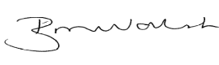  Name: Brian M Walsh  Position: Executive Director  People Directorate |   Signature;   Name: Kay St Clair  Position: Chief Executive Officer
  Signature:  Name: Rachel Newson  Position: Chief Executive |     Signature:  Name: David Eltringham  Position: Chief Operating Officer
  Signature: 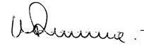  Name: Dr Adrian Canale-Parola  Position: Chair of Coventry and Rugby CCG | 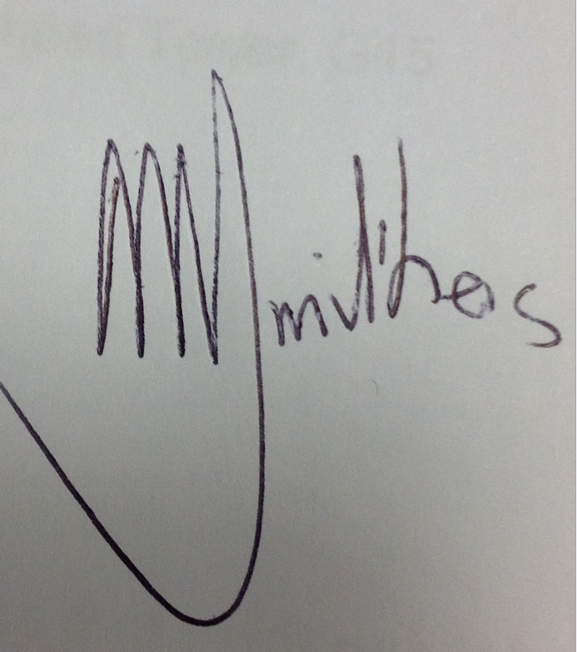  Signature:  Name: Dr Andrew Smithers  Position: Mental Health Lead
    Signature:  Name: Jon Waterman  Position: Operations Commander |   Signature: 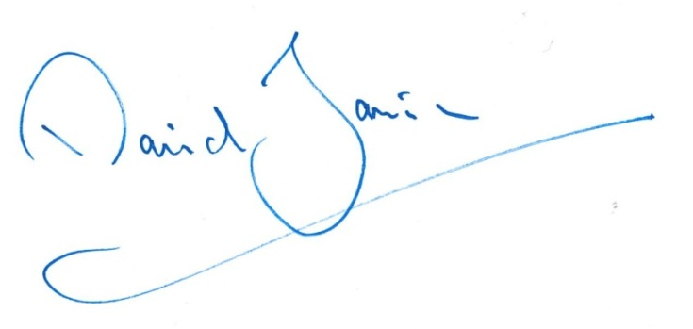  Name: David Jamieson  Position: Police and Crime Commissioner
  Signature:   Name: Allan Gregory  Position: Superintendent | Signature: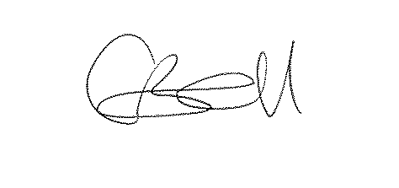  Name: Claire Bell  Position: Chief Superintendent
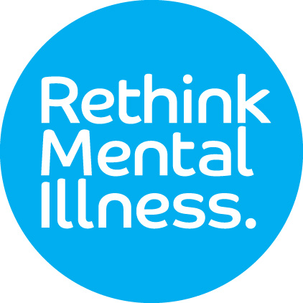  Signature 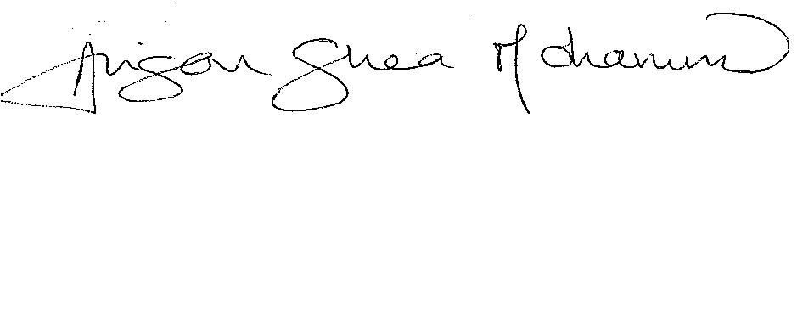  Name: Alison Shea Mohammed  Position: Chief Operating Officer |   Signature : 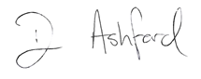  Name: David Ashford  Position: Head of Clinical Practice – MH




Signature: 

Name: Hugh Jobber

Position: Regional Director (North & West)

Who should sign a local Declaration?
Many local organisations want to support the Declaration because of their commitment to improve mental health care and may want to make a specific contribution within the action plan for continuous improvements.
In addition, certain organisations have a formal (statutory) responsibility and/or a professional duty of care regarding people presenting in mental health crisis:
- Clinical Commissioning Groups
- NHS England Local Area teams (primary care commissioners)
- Commissioners of social services
- The Police Service
- Police and Crime Commissioners
- The Ambulance Service
- NHS providers of Urgent and Emergency Care (Emergency Departments within local hospitals)
- Public / independent providers of NHS funded mental health services
- Public / independent providers of substance misuse services

Glossary of terms used in this declaration

Concordat | A document published by the Government.  The Concordat is a shared, agreed statement, signed by senior representatives from all the organisations involved. It covers what needs to happen when people in mental-health crisis need help.  It contains a set of agreements made between national organisations, each of which has a formal responsibility of some kind towards people who need help. It also contains an action plan agreed between the organisations who have signed the Concordat.  Title: Mental Health Crisis Care Concordat – Improving outcomes for people experiencing mental health crisis  Author: Department of Health and Concordat signatories  Document purpose: Guidance  Publication date: 18th February 2014  Link:  https://www.gov.uk/government/uploads/system/uploads/attachment_data/file/281242/36353_Mental_Health_Crisis_accessible.pdf
Mental health crisis | When people – of all ages – with mental health problems urgently need help because of their suicidal behaviour, panic attacks or extreme anxiety, psychotic episodes, or behaviour that seems out of control or irrational and likely to put the person (or other people) in danger.
Parity of esteem | Parity of esteem is when mental health is valued equally with physical health.  If people become mentally unwell, the services they use will assess and treat mental health disorders or conditions on a par with physical illnesses.  Further information:  http://www.england.nhs.uk/ourwork/qual-clin-lead/pe
Recovery | One definition of Recovery within the context of mental health  is from Dr. William Anthony:  “Recovery is a deeply personal, unique process changing one’s attitude, values, feelings, goals, skills, and/or roles.  It is a way of living a satisfying, hopeful, and contributing life.  Recovery involves the development of new meaning and purpose  in one’s life as one grows beyond the catastrophic effects of psychiatric disability”  (Anthony, 1993)  Further information http://www.imroc.org/

