The 2014 Shropshire Declaration on improving outcomes for people experiencing mental health crisis Wednesday 3rd September 2014.

We, as partner organisations in Shropshire, will work together to put in place the principles of the national Concordat to improve the system of care and support so that people in crisis because of a mental health condition are kept safe. We will help them to find the help they need − whatever the circumstances − from whichever of our services they turn to first.

We will work together to prevent crises happening whenever possible, through intervening at an early stage.

We will make sure we meet the needs of vulnerable people in urgent situations, getting the right care at the right time from the right people to make sure of the best outcomes.

We will do our very best to make sure that all relevant public services, contractors and independent sector partners support people with a mental health problem to help them recover. Everybody who signs this declaration will work towards developing ways of sharing information to help front line staff provide better responses to people in crisis.

We are responsible for delivering this commitment in Warwickshire and West Mercia by putting in place, reviewing and regularly updating the attached action plan.

This declaration supports ‘parity of esteem’ (see the glossary) between physical and mental health care in the following ways:
- Through everyone agreeing a shared ‘care pathway’ to safely support, assess and manage anyone who asks any of our services in Shropshire for help in a crisis. This will result in the best outcomes for people with illness, provide advice and support for their carers, and make sure that services work together safely and effectively.
- Through agencies working together to improve individuals’ experience (professionals, people using services at time of crisis, and carers) and reduce the likelihood of harm to the health and wellbeing of patients, carers and professionals and wider community.
- By making sure there is a safe and effective service with clear and agreed policies and procedures in place for people in crisis, and that organisations can access the service and refer people to it in the same way as they would for physical health and social care services.
- By all organisations who sign this declaration working together and accepting our responsibilities to reduce the likelihood of future harm to patients, service users, carers, wider community, staff and to support people’s recovery and wellbeing.

We, the organisations listed below, support this Declaration. We are committed to working together to continue to improve crisis care for people with mental health needs in Shropshire.

Who should sign a local Declaration?
Many local organisations want to support the Declaration because of their commitment to improve mental health care and may want to make a specific contribution within the action plan for continuous improvements.
In addition, certain organisations have a formal (statutory) responsibility and/or a professional duty of care regarding people presenting in mental health crisis:
- Clinical Commissioning Groups
- NHS England Local Area teams (primary care commissioners)
- Commissioners of social services
- The Police Service
- Police and Crime Commissioners
- The Ambulance Service
- NHS providers of Urgent and Emergency Care (Emergency Departments within local hospitals)
- Public / independent providers of NHS funded mental health services
- Public / independent providers of substance misuse services

  David Shaw  Chief Constable  West Mercia Police Headquarters   | 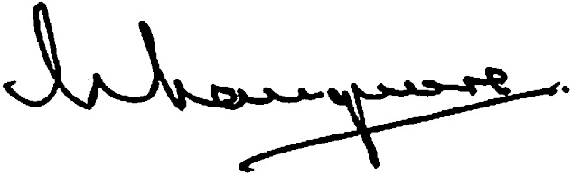  Bill Longmore  West Mercia Police and Crime Commissioner  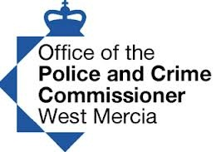 |  |  | 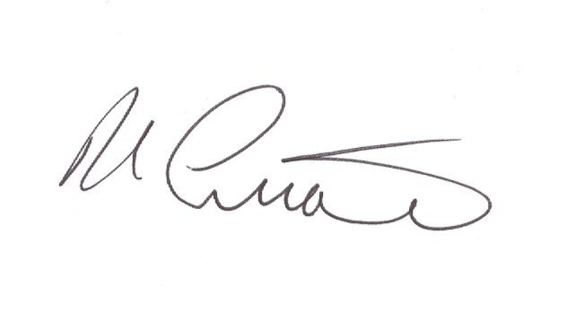    Tom Currie  Assistant Chief Officer  Head of Service NPS West Mercia | 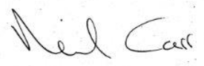  Neil Carr  Chief Executive Officer  South Staffordshire and Shropshire Healthcare NHS Foundation Trust  
  Clive Ireland  Chairman  Shropshire Mind   | 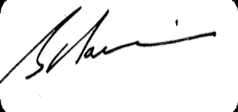 Simon Hairsnape  Chief Officer  NHS Redditch and Bromsgrove Clinical Commissioning Group  NHS Wyre Forest Clinical Commissioning Group |  |  | 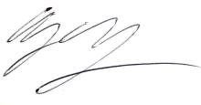  Dr Richard Harling  Director  Adult Services and Health  Worcestershire County Council  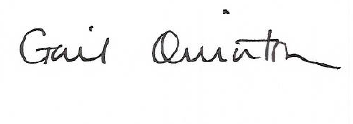  Gail Quinton  Director of Children's Services  Worcestershire County   | 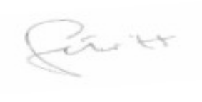Simon Trickett  Chief Operating Officer NHS South Worcestershire Clinical Commissioning Group  
  
  
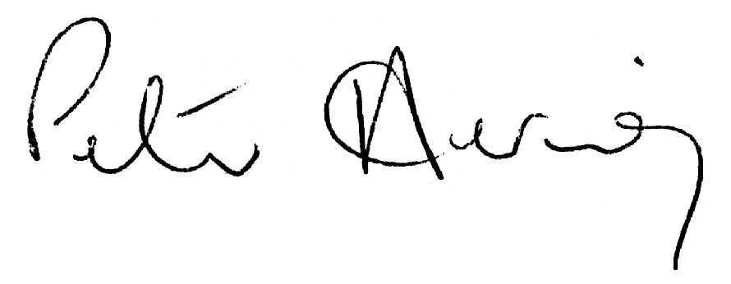  Peter Herring  Chief Executive  Shrewsbury and Telford Hospitals (SATH) |  | 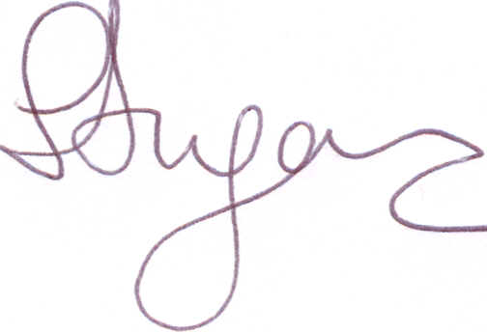  Sarah Dugan  Chief Executive  Worcestershire Health and Care NHS   |  | 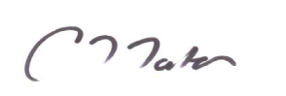  Caron Morton  Accountable Officer  Shropshire Clinical Commissioning Group   | 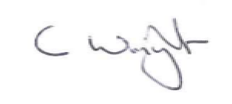  Clive Wright  Chief Executive  Shropshire Council  
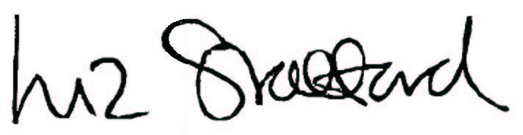  Liz Stafford  Chief Executive  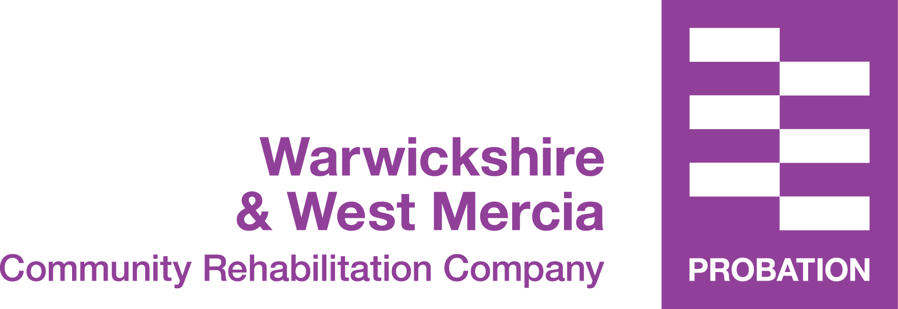  Warwickshire and West Mercia Community Rehabilitation Company | 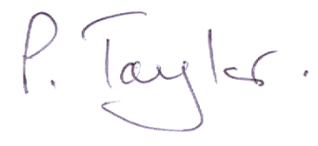  Paul Taylor  Director: Health, Wellbeing & Care    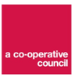  Telford & Wrekin Council |  |  | 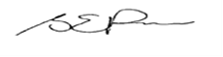  Sue Price  Director of Commissioning    Arden, Herefordshire and Worcestershire Area Team NHS England |  | 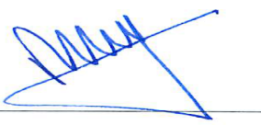  Richard Kelly  Executive Director  Herefordshire Mind  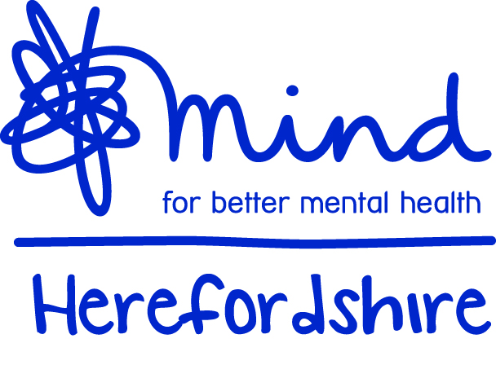
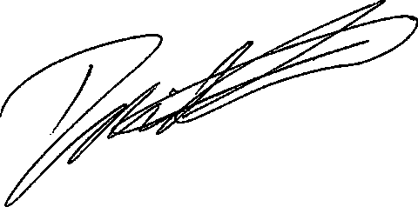  David Evans  Chair & Chief Officer  NHS Telford and Wrekin Clinical Commissioning Group   |  |  | 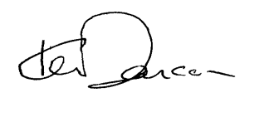  Dr Ken Deacon  Medical Director/ Interim Director of Commissioning  Shropshire & Staffordshire Area Team NHS England   | 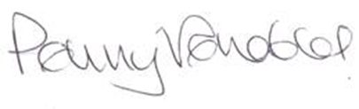  Penny Venables  Chairman and Chief Executive  Worcestershire Acute Hospitals NHS Trust   |  | 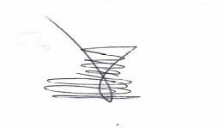  Steven Gregory  Director of Nursing and Operations  Shropshire Community Health NHS Trust  
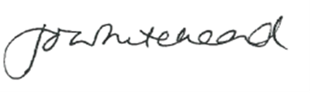  Jo Whitehead  Chief Officer  Herefordshire Clinical Commissioning Group   |  |  | 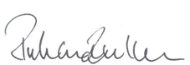  Richard Beeken  Chief Executive Officer  Hereford Wye Valley Trust   | 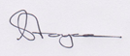  Sam Joyce  Chief Executive Officer  Telford Mind  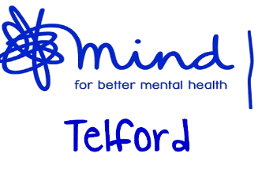 |  | 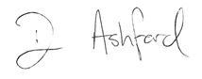  David Ashford  Head of Clinical Practice – Mental Health  
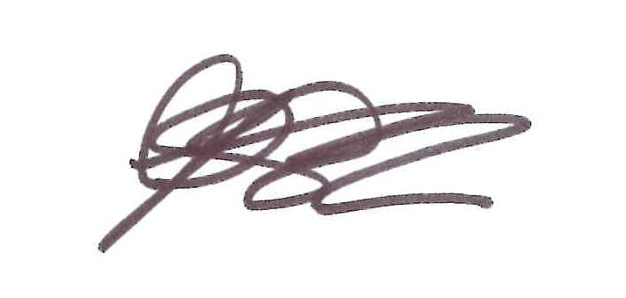  Helen Coombes  Herefordshire Council Adults and Wellbeing  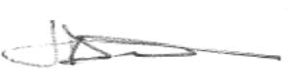  Jo Davidson  Herefordshire Council Childrens and Family   |  |  | 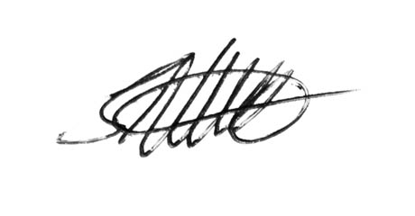  Shaun Clee  2gether NHS Foundation Trust (Herefordshire)  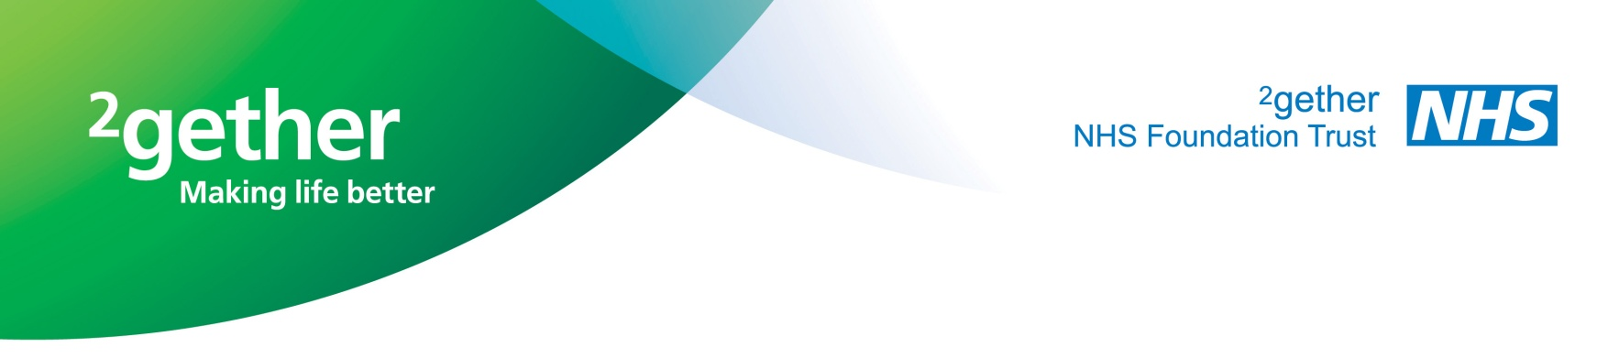 | 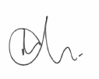Allan Gregory  Superintendent  British Transport Police  

