The 2014 Warwickshire Declaration on improving outcomes for people experiencing mental health crisis Wednesday 3rd September 2014.

We, as partner organisations in Warwickshire, will work together to put in place the principles of the national Concordat to improve the system of care and support so that people in crisis because of a mental health condition are kept safe. We will help them to find the help they need − whatever the circumstances − from whichever of our services they turn to first.

We will work together to prevent crises happening whenever possible, through intervening at an early stage.

We will make sure we meet the needs of vulnerable people in urgent situations, getting the right care at the right time from the right people to make sure of the best outcomes.

We will do our very best to make sure that all relevant public services, contractors and independent sector partners support people with a mental health problem to help them recover. Everybody who signs this declaration will work towards developing ways of sharing information to help front line staff provide better responses to people in crisis.

We are responsible for delivering this commitment in Warwickshire and West Mercia by putting in place, reviewing and regularly updating the attached action plan.

This declaration supports ‘parity of esteem’ (see the glossary) between physical and mental health care in the following ways:
- Through everyone agreeing a shared ‘care pathway’ to safely support, assess and manage anyone who asks any of our services in Warwickshire and West Mercia for help in a crisis. This will result in the best outcomes for people with illness, provide advice and support for their carers, and make sure that services work together safely and effectively.
- Through agencies working together to improve individuals’ experience (professionals, people using services at time of crisis, and carers) and reduce the likelihood of harm to the health and wellbeing of patients, carers and professionals and wider community.
- By making sure there is a safe and effective service with clear and agreed policies and procedures in place for people in crisis, and that organisations can access the service and refer people to it in the same way as they would for physical health and social care services.
- By all organisations who sign this declaration working together and accepting our responsibilities to reduce the likelihood of future harm to patients, service users, carers, wider community, staff and to support people’s recovery and wellbeing.

We, the organisations listed below, support this Declaration. We are committed to working together to continue to improve crisis care for people with mental health needs in Warwickshire.

Who should sign a local Declaration?
Many local organisations want to support the Declaration because of their commitment to improve mental health care and may want to make a specific contribution within the action plan for continuous improvements.
In addition, certain organisations have a formal (statutory) responsibility and/or a professional duty of care regarding people presenting in mental health crisis:
- Clinical Commissioning Groups
- NHS England Local Area teams (primary care commissioners)
- Commissioners of social services
- The Police Service
- Police and Crime Commissioners
- The Ambulance Service
- NHS providers of Urgent and Emergency Care (Emergency Departments within local hospitals)
- Public / independent providers of NHS funded mental health services
- Public / independent providers of substance misuse services

Warwickshire Signatories

  Andy Parker  Chief Constable Warwickshire Police   | 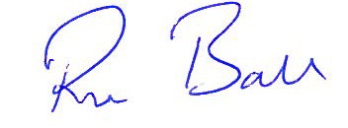  Ron Ball  Police and Crime Commissioner   | 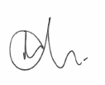  Allan Gregory  Superintendent  British Transport Police   | 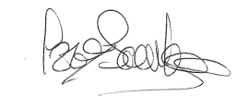  Izzi Seccombe  Leader Warwickshire County Council  
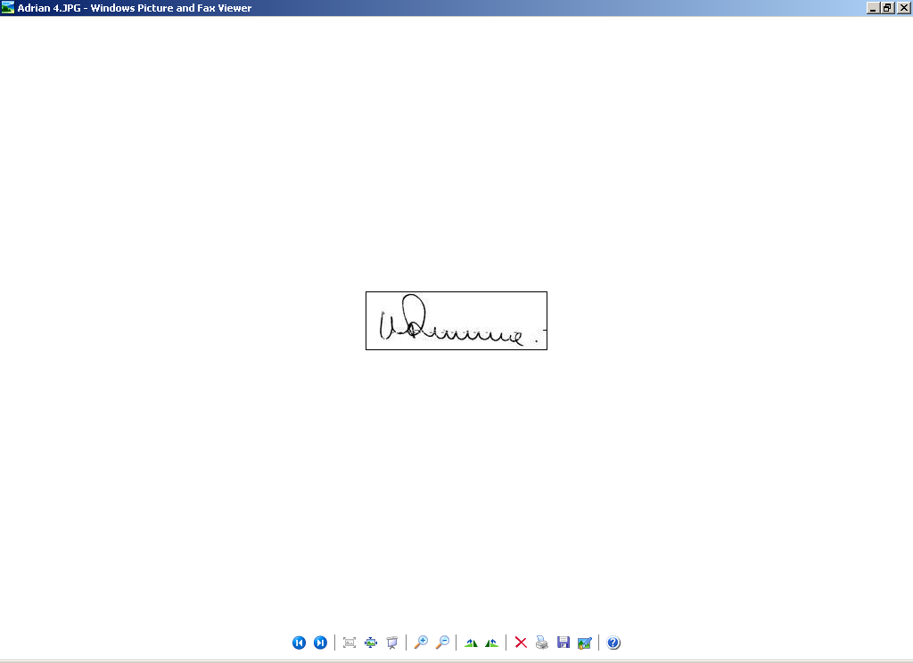  Dr Adrian Canale-Parola  NHS Coventry and Rugby CCG   | Gillian Entwistle  Gillian Entwistle  Chief Officer  NHS South Warwickshire CCG | 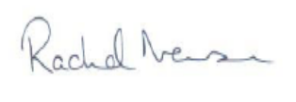  Rachel Newson,  Chief Executive Coventry and Warwickshire  Partnership Trust NHS   | 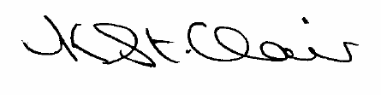  Kay St. Clair  Chief Executive Officer  Coventry and Warwickshire  
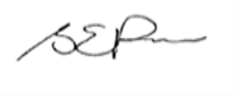  Sue Price  Director of Commissioning  Arden, Herefordshire and Worcestershire  Area Team NHS England   |   Glen Burley  Chief Executive  South Warwickshire NHS Foundation Trust   | 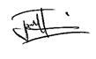  Junaid Hussain  Warwickshire Race Equality Partnership   | 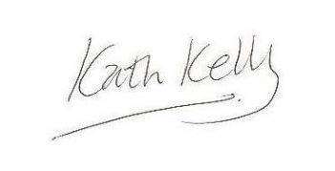  Kath Kelly  Chief Executive  George Eliot Hospital NHS Trust  
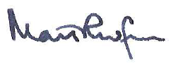  Professor Mark Radford- Chief Nursing Officer  On behalf of UHCW Chief Executive Andy Hardy  University Hospitals Coventry and Warwickshire   | 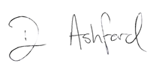  Dave Ashford  Head of Clinical Practice  West Midlands Ambulance Service NHS FT   | 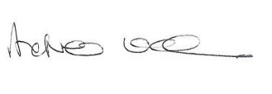  Andy Wade  Head of Coventry, Solihull & Warwickshire  National Probation Service I Midlands Division   | 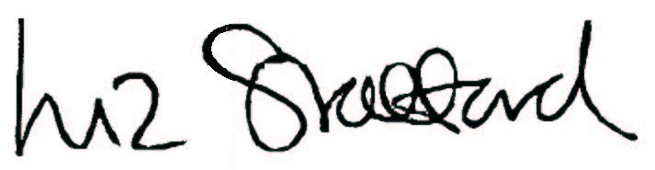  Liz Stafford  Chief Executive  Warwickshire and West Mercia Community Rehabilitation Company  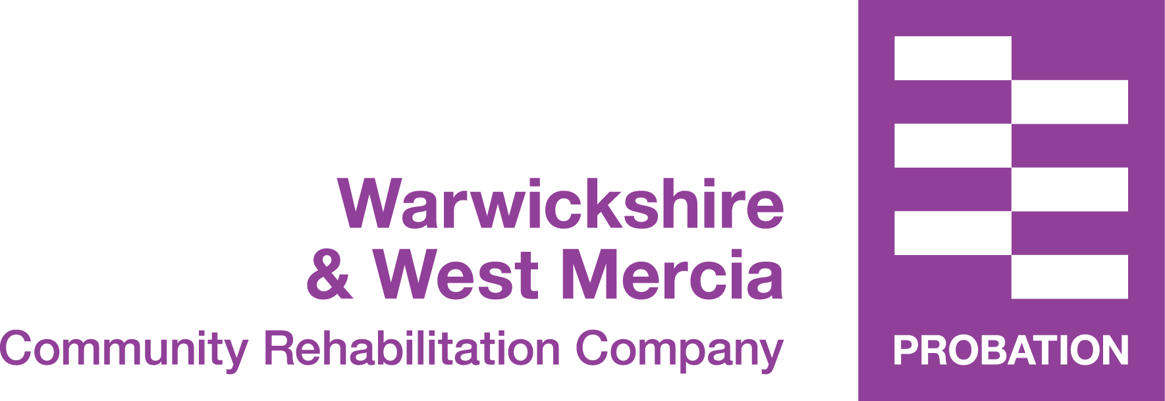

Andrea J Green
Chief Officer
NHS Warwickshire North Clinical Commissioning Group


