[](http://www.google.co.uk/url?sa=i&source=imgres&cd=&ved=0CAkQjRwwAGoVChMInvX5_5_YxwIVgekUCh1ldA6y&url=https://www.jobs.enfield.gov.uk/&psig=AFQjCNGiyk41ZMA8zjdNoZipa31V-Zt7Ug&ust=1441279856085741)****

[Metropolitan Police Service](http://content.met.police.uk/Home)

**Enfield Community Services**

**Hosted by BEH-MHT**

**BARNET, ENFIELD AND HARINGEY CCG’S JOINT CRISIS CONCORDAT ACTION PLAN**

**V10. October 2015**

[](http://www.londonambulance.nhs.uk/)[](http://www.google.co.uk/url?sa=i&rct=j&q=&esrc=s&frm=1&source=images&cd=&cad=rja&uact=8&ved=0CAcQjRw&url=http://www.clch.nhs.uk/&ei=ZPUSVZaEAsL0PPv_gegF&bvm=bv.89184060,d.ZWU&psig=AFQjCNGmQt2H6rF0CwiT8FVIQ7B0Flzq5A&ust=1427390531884190)[](https://statement.secure.haringey.gov.uk/)

Keith Dean, Mental Health Commissioner Enfield CCG, Jackie Liveras, Assistant Director of Patient Services. October 2015

Introduction

NHS Barnet, Enfield and Haringey CCG’s (BEH) made a commitment to the Mental Health Crisis Care Concordat (MHCCC) by being signatories to the Pan-London declaration. The CCG’s are committed to working in partnership to improve the experience and services commissioned for people living with mental health conditions; we are therefore working in partnership across BEH to deliver the principles of the Crisis Care Concordat.

The BEH MHCCC action plan May 2015 was developed following an assessment against the standards. This was undertaken by the mental health commissioners with specialist external support. Information was also gathered from local multi-agency groups.

This updated action plan has been co-produced by Commissioners and Barnet Enfield & Haringey Mental Health Trust (BEHMHT), our main mental health provider, and is further supported with on-going engagement across the legal, health and social care system, including service users and their carers.

Local Work streams have been developed with partners and delivery will be overseen by the NHS Barnet Enfield and Haringey CCG’s local Mental Health Delivery Groups and the BEHMHT Inter Agency Mental Health Law Monitoring Group to ensure that the 4 main areas of the Crisis Care Concordat are addressed which also support local improvements to Enablement/Recovery, Resilience and mental health crisis care; however the opportunity is now presented to develop and link projects, models and work areas, which will also support commissioning plans and service delivery. In addition published borough level mental health public health publications also inform on local areas of focus and need.

This updated MHCCC action plan is designed to: -

1. Focus on the four pillars of the Crisis care Concordat

* [Access to support before crisis point](http://www.crisiscareconcordat.org.uk/about/#access)
* [Urgent and emergency access to crisis care](http://www.crisiscareconcordat.org.uk/about/#urgent)
* [Quality of treatment and care when in crisis](http://www.crisiscareconcordat.org.uk/about/#quality)
* [Recovery and staying well](http://www.crisiscareconcordat.org.uk/about/#recovery)

1. Encourage inter agency working to maximise innovation and encourage new ideas and new ways of working
2. Ensure the Service Users are at the centre of all our plans, their voice is heard, listened too and embraced in our plans
3. Ensure national and local guidance and standards are met
4. Provide a comprehensive governance framework for delivery, scrutiny and assurance, ensuring
   * 1. Quality is at the heart of everything we do
     2. Work streams will have identified measurable outcomes.

Please see Governance Chart(s) below

**Chart 1. NHS Overarching Governance Structure**

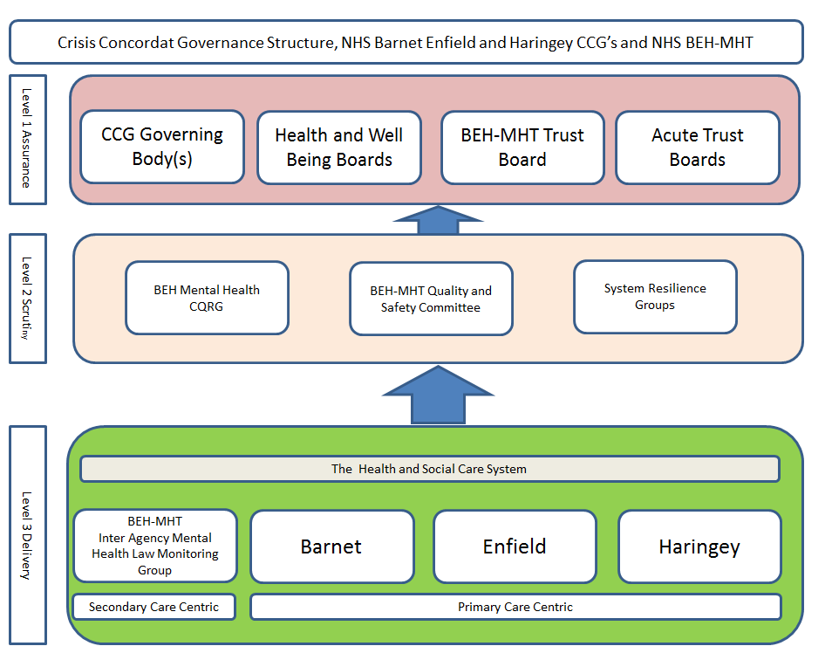

Quality is at the heart of everything we do.

**Chart 2. Barnet Borough Governance Structure**

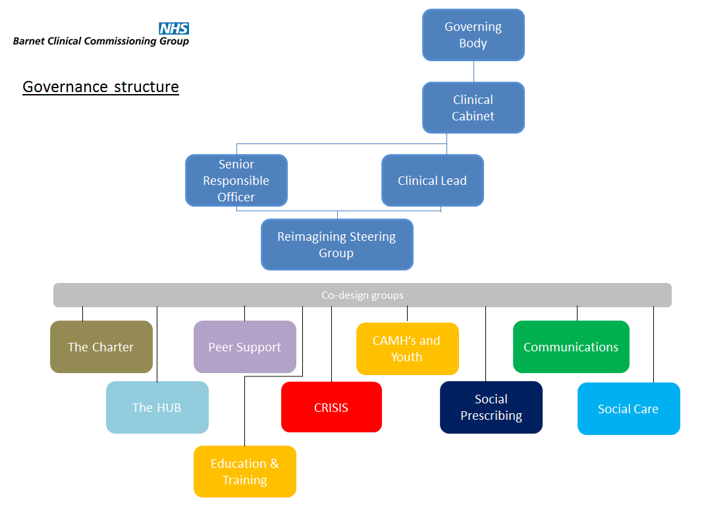

**Chart 3. Enfield Borough Governance Structure**

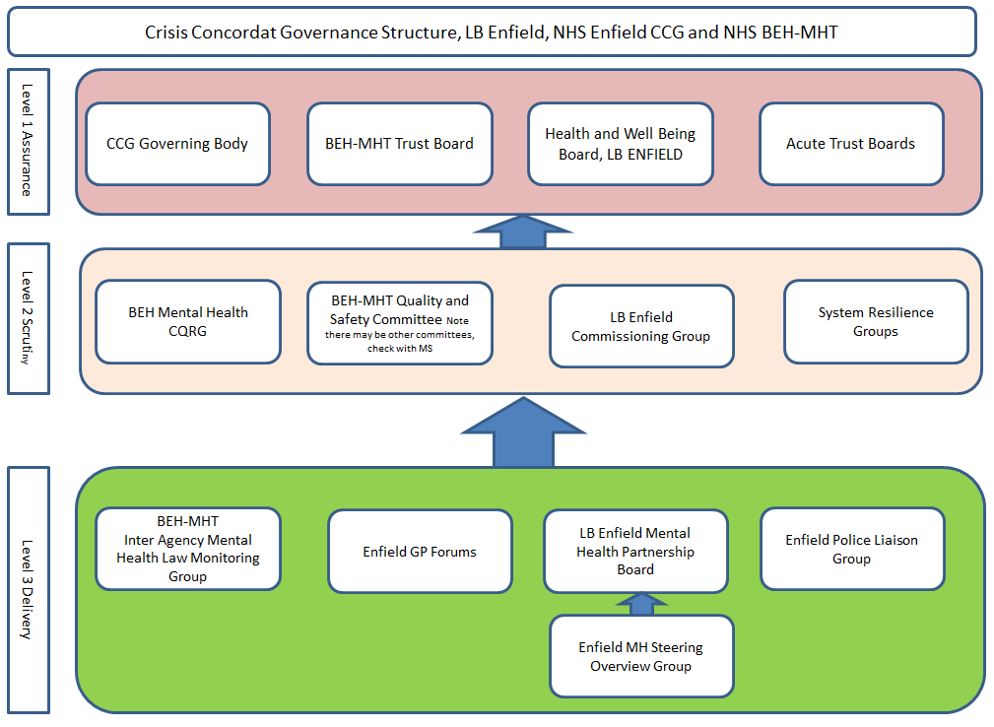

Chart 4. Haringey Borough Governance Structure

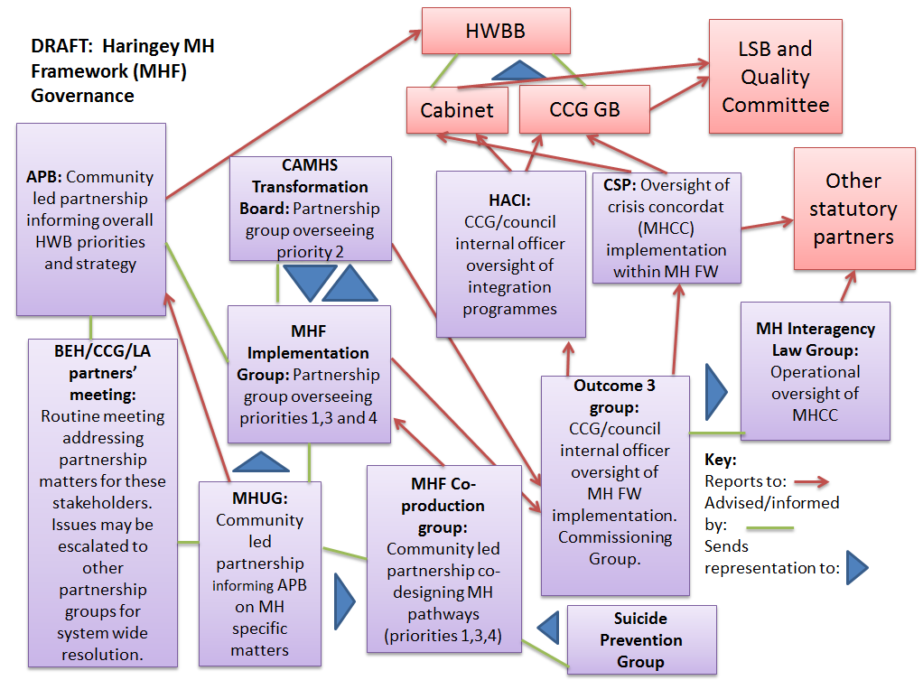

Actions to Support the delivery of the Concordat

1. **Re define the roles and TOR’s of all groups identified to have responsibilities for all or part of Crisis Care Concordat Delivery across Barnet Enfield and Haringey which collectively cover the whole system and organisations.**

**Judicial/legal**

**Local Authority,**

**LAS**

**NHS Primary Care**

**NHS Secondary Care (BEH-MHT and Acute Trusts)**

**NHS Community Care**

**3rd sector, community and service user/carer organisations**

1. **For Guidance TOR’s Should**
   1. **Define their respective scope**
   2. **Oversee the planning, review and implementation of work streams**
   3. **Adoption/implementation of current national and London guidance, standards and reports.**
   4. **Agree information reports to support outcomes - monitoring and assurance of service delivery and inform future Commissioning Intentions/service design. Example – Access and response times.**
   5. **Promote opportunities for new ways of working (potential business case developments across health and social care), communication and education across the multi agencies involved in crisis care.**
   6. **Ensure engagement with service users and carers as appropriate to agreed work streams.**
   7. **Build on work to date. Examples include**

* **Consideration of CQC report ‘Right Here Right Now’ findings and recommendations**
* **Take note of the borough level Suicide Prevention works streams and forums**
* **Mental Health Liaison performance reports within A&E and acute Trust inpatient services.**
* **S135/136 Mental health Act Assessments, Police assessment and links to emergency care**
* **Place of Safety – including travel to Place of Safety**
* **Consideration of relationship interface and operational working of AMP’s and the Crisis Services**
* **The Carnall-Farrar detailed report on activity and performance of secondary care services gives valuable insight into the commissioning opportunities for partnership working, design and delivery.**

Updated Plan –

Lead Forum Key:

TB = Tri borough Forum(s)

B = Borough Forum(s)

**RAG Key: -**

**Red – Not started or not scoped**

**Amber -Work in progress against timescale**

**Green - Completed**

|  |  |  |  |  |  |  |
| --- | --- | --- | --- | --- | --- | --- |
| 1. **Access to Support Before Crisis Point** | | | | | | |
| **No.** | **Action** | **Timescale** | **Led By** | **Outcomes** | **Lead Forum** | **RAG** |
| **1.1** | **Information**  Build on work to date ensuring accessible, suitable information for patients, their carers and each of the main agencies who deal with MH crisis on how to manage crisis issues locally, which agencies are appropriate to contact, thresholds for services and alternative service provision. | On going | BEH MHT  LA Commissioners,  Police  Voluntary sector | 1. Development of web and paper based information on how and where to access information. To include threshold and eligibility threshold. 2. Equip local universal services (e.g. Citizens Advice) to be able to respond to information requests and initial signposting.   To be informed further from service user engagement events | TB+B |  |
| **1.2** | **Phone Hub**  Following Commissioner visit and engagement in the Phone Hub:   1. Agree with the provider relevant performance reports that provide assurance of hub response times, effective and timely handling of calls, appropriate signposting and call outcomes. 2. Be assured the Hub operates 24/7 3. Scrutinise service user surveys routinely collated by the Hub team relating to patient experience of using the service. 4. Engage with service users for feedback on hub services. 5. Work with the provider to establish if GP referrals are consistent across BEH regarding referral criteria and thresholds. Oversee partnership plans for primary and secondary care providers to resolve. 6. Commissioners to work with the provider to understand what calls are screened out for whatever reasons and what gap analysis opportunities this identifies to inform future commissioning plans. 7. Work in partnership between the Hub and Primary Care to further build on the referral pathway process for access to relevant teams if caller signposted to other services. | On-going, commenced with Commissioners Site visit 01/09/15, 05/10/15 and 21/10/15  To report by January 2016 | CCG commissioners  BEH MHT,  GPs  Police | Outcome of study to be shared including GPs.  Survey results to be presented to the Quality and Performance Review Meeting on a regular basis  Review any issues or opportunities and develop delivery plans | TB |  |
| **1.3** | **Training**  Health and Social Care  Identify how mental health training of all types covers crisis prevention and management across the system.  Primary Care,  Secondary Care,  Local Authorities  Police  For review by the Delivery Groups and development of training Plan. |  | BEH MHT  BEH Police leads  CCG & LA commissioners | Clear understanding of training available to partners and gaps to inform future commissioning.  Ensure a consistent level of knowledge and expertise to manage and prevent mental health crises. | TB |  |
| **1.4** | Following the work of the Recovery House Review Group, work with partners to ensure delivery of the step up/step down model with agreed referral protocols and processes for access |  | BEH MHT  CCG commissioners | New Service Specification worked up and agreed with stakeholders. | TB |  |
| **1.5** | Young People under 18 years  **To be informed by the Commissioner led CAMHS Transformation Plans in accordance with ‘*Future in Mind 2015’* which will be submitted to NHS E 16/10/15** | Submission date for Plan 16/10/15 | CAMHS providers, CCG Children’s Commissioners, Local Authority Children’s Services | Awaiting feedback post submission of plans |  |  |
| **1.6** | **Transition between CAMHS and AMHS, as above re ‘Future in Mind’ as above following 16/10/15** | Submission date for Plan 16/10/15 | CAMHS providers, CCG Children’s Commissioners, Local Authority Children’s Services | Awaiting feedback post submission of plans |  |  |

|  |  |  |  |  |  |  |
| --- | --- | --- | --- | --- | --- | --- |
| 1. [**Urgent and emergency access to crisis care**](http://www.crisiscareconcordat.org.uk/about/#urgent) | | | | | | |
| **No.** | **Action** | **Timescale** | **Led By** | **Outcomes** | **Lead Forum** | **RAG** |
| **2.1** | **Commissioners to be assured of adherence to:**  NICE Quality Standards for service user experience in adult mental health  **Quality statement 10: Assessment in a crisis.**  “(Concordat) partners ensure systems are in place for mental health service users accessing crisis support to have a comprehensive assessment undertaken by a professional competent in crisis working”.  Commissioners and Trust to agree specific areas of focus re NICE quality standards | March 2016 | CCG’s  Crisis Care Concordat Delivery Groups in partnership with BEH MHT | People accessing crisis support have a comprehensive assessment, undertaken by a professional competent in crisis working.  A comprehensive assessment includes details of the person's:   * relationships with others * social and living circumstances * level of functioning * symptoms * behavior * diagnosis * current treatment   Commissioners to be assured via Delivery/assurance groups of the quality of assessment during crisis presentation. | TB |  |
| **2.2** | **Service User Engagement and Feedback 2015**   * Consideration of pathways for community and other alternative support, especially where service users are re directed away from CRHT to other services, - Develop a service directory or ‘one stop shop’ concept. * Hub Team Service User Surveys relating to patient satisfaction/experience of using the service. * Consideration to developing a service user charter | March 2016 |  | Develop an ongoing feedback system to crisis staff and service users to enable service design to be further informed and co-produced | TB |  |
| **2.3** | **Place of Safety**  Delivery groups to seek assurance of:   * Local arrangements to ensure that people admitted to a 'place of safety' are assessed under the Mental Health Act within 4 hours. * Adherence to Pan London protocol for Place of Safety. | On going | CCG’s, BEH-MHT, LA’s, Met Police | Deliver service that is compliant with NICE) *Quality Standards for service user experience in adult mental health.*  Service users are able to access a local helpline 24 hours a day.  Service users in crisis referred to specialist mental health services were seen within 4 hours.  People admitted to a 'place of safety' were assessed under the Mental Health Act within 4 hours | TB |  |
| **2.4** | **Transfer to Place of Safety (by Ambulance)**  Work with London Ambulance Service to be assured that those in need of Place of Safety are transferred within national protocol response times | March 2016 | CCG’s  London Ambulance Service  Metropolitan Police  BEH MHT  Acute Trusts | Improved working systems with clear escalation processes between emergency responses of A&E, Police and Ambulance services. | TB |  |
| **2.5** | **A&E**  **Mental Health Liaison**  Referenced from ‘Right Here Right Now 2015’   * *“Joint-training sessions for staff run by members of the liaison psychiatry service. “* * *“Improving the environment of A&E departments, and ensuring that people presenting with self-harm related injuries are always treated warmth, compassion and empathy.”*   To ensure that users presenting with mental health needs are triaged effectively, responsibly and on a par with those presenting with a physical difficulty.  Performance monitoring to include   * Mental health Liaison contribution to maintaining national standard A&E 4 hour waits. * Time from arrival in A&E to time of referral to MH Liaison.   **Frequent presentations to A&E**  Develop strategy that will   * Define what is a frequent attender * Identify volume and scale of issue * Promote inter-agency casework to support individuals   **Self-harm**  Parity of Esteem - People who have self-harmed are cared for with compassion and the same respect and dignity as any service user.  Commissioners to be assured that people who have self-harmed have an initial assessment of physical health, mental state, safeguarding concerns, social circumstances and risks of repetition or suicide. | January 16 | CCG’s  BEH MHT  A&E Depts. | Local KPI’s as agreed  To have agreed approach for multi-agency casework approach for frequent attenders to A&E. To be further informed from determination of baselines  To demonstrate compliance with all  NICE quality standards  To be assured of concordance with ‘Right Here Right Now’2015 | TB |  |

|  |  |  |  |  |  |  |
| --- | --- | --- | --- | --- | --- | --- |
| 1. [**Quality of treatment and care when in crisis**](http://www.crisiscareconcordat.org.uk/about/#quality) | | | | | | |
| **No.** | **Action** | **Timescale** | **Led By** | **Outcomes** | **Lead Forum** | **RAG** |
| **3.1** | **Crisis Response to young persons under 16.**  To be informed by the Commissioner led CAMHS Transformation Plans in accordance with ‘*Future in Mind 2015’* | **TBA** | CAMHS providers, CCG Children’s Commissioners, Acute Hospital Paediatric Teams | Implementation of CAMHS Transformation Strategy | TB |  |
| **3.2** | **Assessment**  Be assured of Parity of esteem for service users in crisis is achieved as for physical illnesses across care locations. | On-going  Scoping Complete by June 2016 | BEH MHT, CCGs, LAs, Police, Ambulance Service, Acute Hospitals | Development of quality standards  Please see Met Police Commitments for s136. Embedded below. | TB |  |
| **3.3** | **S136 Protocols**  Assurance re S136 protocols are regularly monitored and reviewed. | On-going | CCG’s  Met Police  BEH MHT | Section 136 protocols in Barnet, Enfield and Haringey are in line with national standards  Please see Met Police Commitments for s136 published to the national crisis care concordat website | TB |  |
| **3.4** | **Timescales for AMHP**  To adhere to timescales for AMHP to respond to assessment requests. | On-going | CCG’s, LA’s, Police  BEH MHT | For review commencing October 2015.  To be discussed at next BEH Inter Agency Law Group. December 2015 | TB |  |
| **3.5** | **Primary Care.**   1. Ensure appropriate communication processes are in place across the health and social care system to assist GP’s in managing mental health patients presenting in crisis and GP able to access appropriate timely support to maximise opportunities to prevent admission to secondary care. 2. Through existing network and locality structures ensure education opportunities/needs to support GP’s in managing mental health patients in the primary care setting are identified and available. | On going | CCG’s, BEH-MHT, LA’s, Primary Care | Agreed protocols and education standards to be developed. | TB |  |

|  |  |  |  |  |  |  |
| --- | --- | --- | --- | --- | --- | --- |
| 1. [**Recovery and Staying Well**](http://www.crisiscareconcordat.org.uk/about/#recovery) | | | | | | |
| **No.** | **Action** | **Timescale** | **Led By** | **Outcomes** | **Lead Forum** | **RAG** |
| **4.1** | **Crisis Recovery and prevention/early warning Plans**  Discharge preparedness from secondary care, ensure recovery focused model of crisis prevention planning in place.  Further develop individualised patient crisis prevention plans co-produced with the service user.  Ensure crisis plans are communicated appropriately especially within Primary Care to enable GP’s and community services to engage and mobilise before crisis point is reached.  Explore opportunities for GP access to specialist rapid re referral/clinical advice to avoid potential crisis readmission | Ongoing | BEH MHT, CCG’s, LA’s, Primary Care | Effective transitions between hospital and community, maximising resources.  Individualised crisis prevention plans in place for crisis service users to encourage early warning and prevention of crisis in the future.  Compliance with quality standards for crisis care and planning.   1. All users who have had in-patient stay and/or detained under MHA should have a clear follow up plan regularly reviewed by the relevant care team. Plans to also include contingency planning for management of potential further crisis. 2. People using mental health services who may be at risk of crisis are fully engaged in the development of and are offered their own crisis plan. | TB |  |
| **4.2** | **Pathway Development**  From secondary care performance reports Commissioners to identify any blockages/issues around discharge and transition to the community. To work in partnership across the system to ensure appropriate patient flow.  To ensure all mental health services across BEH, statutory and voluntary sector, embrace the person-centred, enablement approach to recovery which promotes self, household and community resilience | Ongoing | BEH MHT, CCG’s, LA’s, Primary Care | Development of co-produced plans to enable independence, promote individual resilience and measure/reduce the incidence of re admissions | TB |  |
| **4.3** | **Service user Engagement of experience of crisis care**  Engage with service users seeking their views of crisis care to inform on future commissioning intentions.  User satisfaction surveys are integral to published BEH-MHT Quality Assurance reports | On-going | CCG Commissioners, Voluntary sector | Service user engagement event feedback is being used to inform crisis care management and opportunities for co-produced services in Barnet Enfield and Haringey. | TB |  |